FOR NEW CLUSTER INSTALLATION

This installation manual is for create cluster server.
Requisites
- Edit hosts
- Create host name
- Fix static ip on both server
- Master server install (Fas , fcsdk , & La)
- Slave server install only Fas

- First go to master & Slave server and edit hosts and paste master/slave server name with ip.
for example:-

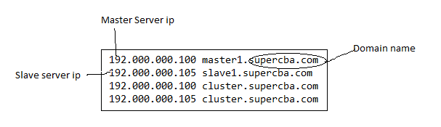

- Edit hostname in both master & slave server and paste master and slave server name.

for example:- in master server vi /etc/hostname
master1.supercba.com

in Slave server vi /etc/hostname
slave1.supercba.com

- Fix Ip in both master and slave server :-

vi /etc/sysconfig/network-scripts/ifcfg-ens192

TYPE="Ethernet"
PROXY_METHOD="none"
BROWSER_ONLY="no"
BOOTPROTO="static"
DEFROUTE="yes"
IPV4_FAILURE_FATAL="no"
IPV6INIT="yes"
IPV6_AUTOCONF="yes"
IPV6_DEFROUTE="yes"
IPV6_FAILURE_FATAL="no"
IPV6_ADDR_GEN_MODE="stable-privacy"
NAME="ens192"
UUID="a98eb8f3-0207-49cb-8b98-5dc7ae33edf0"
DEVICE="ens192"
ONBOOT="yes"
IPADDR=192.000.000.100 (Master server ip – in master server and Slaver server ip in slave server )
GATEWAY=192.000.000.1(Gateway Ip)
NETMASK=255.000.000.0(Subnet mask)
DNS1=8.8.8.8(Dns server Ip)
Note :- after static ip Update Kindly run - service network restart

- Master server installation (Fas , Fcsdk , La)

FAS:-

vi as-installer-2.5.21.advanced-install.properties
accept.eula=yes
JDKPath=/usr/java/latest
topology.type=multibox
node.type=master
bind.address.service=master1.supercba.com
bind.address.management=master1.supercba.com
cluster.address=cluster.supercba.com

Fcsdk:-

vi fusion_client_core_sdk_installer-3.3.18.advanced-install.properties
accept.eula=yes
JDKPath=/usr/java/latest
packs=COMMON,GATEWAY,CORE_SDK,MEDIABROKER,SAMPLE_APP
appserver.admin.address=master1.supercba.com
gateway.controlled_domain=cluster.supercba.com

La :-
vi cafex_live_assist_installer-1.64.4.production.properties
accept.eula=yes
JDKPath=/usr/java/latest
appserver.admin.address=master1.supercba.com

- Slave server installation :- Only install Fas in Slave server
vi as-installer-2.5.21.advanced-install.properties
accept.eula=yes
JDKPath=/usr/java/latest
topology.type=multibox
node.type=slave
bind.address.service=slave1.supercba.com
bind.address.management=slave1.supercba.com
master.address=master1.supercba.com

Note :- After complete check any system first edit hosts and paste master and slave details for open
click on file and open C:\Windows\System32\drivers\etc\hosts

